Dear Volunteers
Welcome to our Club! Thank you for volunteering. Your contribution to our Club is highly valued and we trust you will find it a rewarding experience.
As a Volunteer, you are an ambassador for our Club both on game day and in our local community. As an ambassador for our Club, your most significant role is presenting our values and contributing to our strong, positive and supportive culture that has seen our Club thrive for many years, on and off the field.
The NRL National Code of Conduct is the foundation of our Clubs beliefs and values. Volunteers are expected to adhere to the NRL National Code of Conduct, which has proven to establish our standards, and makes our Club a welcoming destination for the community to enjoy the game of Rugby League.
As Volunteers, we all must abide by the NRL National Code of Conduct, and we ask you to pledge the following:
- I pledge to create and foster a safe, inclusive and welcoming environment for all of our members and visitors
- I pledge to be supportive of other volunteers and match officials both at our Club and in the greater Rugby League community
- I pledge to be accountable for my responsibilities and complete them to the best of my ability
- I pledge to understand my responsibilities under the NRL National Code of Conduct and agree to behave in a way that acknowledges and aligns with those responsibilities
- I pledge to lead by example and display respect for our Club, our opponents, our match officials and all members of our Rugby League family.
By making this pledge, you are helping our Club implement our values and culture.
Through the words and actions of all our members, our Club’s culture will continue to develop and grow, and leave a positive impact in our community.
This is ‘OUR CLUB, OUR PEOPLE, OUR CULTURE’
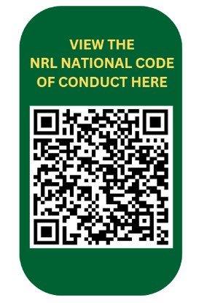
Signed

(Club President) (Club Secretary)

