Dear Players
Welcome to our Club! Thanks for signing up and we hope you have a great season with the team.
As your Coach, I am responsible for the team and for making sure that you enjoy your experience while you learn the foundation skills of Rugby League.
I have another really important job, and that is to teach you the values of our Club and show you how you can contribute to the strong and positive culture that our Club has. It is also my job to show you how good behaviour can help everyone enjoy their experience. Not only other players, but our referees, our parents and spectators and our volunteers, and most importantly, YOU!
As your Coach, I will abide by our Clubs values, and I promise to do the following:
- I will make sure that as players, you always feel safe and included in your team and your Club
- I will make sure you learn to play fair, always try your best, and have fun through good teamwork and sportsmanship
- I will always reward effort and enthusiasm, and will do my best to never criticise any of you
- I understand my responsibilities under the NRL National Code of Conduct and agree to behave in a way that acknowledges and aligns with the Code
- I will lead by example and display respect for our Club, our opponents, and all members of our Rugby League family and encourage the same positive behaviours from all of you.
As players, you also have responsibilities to the team and the Club. The NRL National Code of Conduct outlines the good behaviours that the game expects you to display. We as a Club, ask that you read and understand the NRL National Code of Conduct and how it applies to you as players. We ask you to:
- Be a good sport
- Always show respect to other participants, be it players, volunteers or referees
- Never become involved in acts of foul play
- Most importantly, make sure you are enjoying the game!
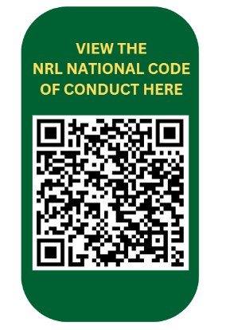
Through the words and actions of all of our us at the Club, we will continue to develop and grow.
This is ‘OUR CLUB, OUR PEOPLE, OUR CULTURE’
Signed

(Team Manager)

